Logging in to Wi-Fi (Windows 7)
1. Click on the network icon. Select the required network and click Connect
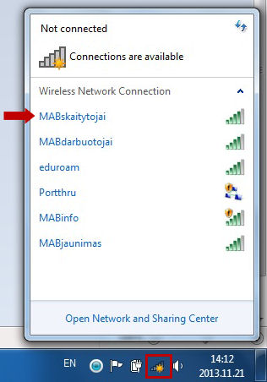

2. In the first field, enter your reader’s card number (a), in the second field, enter your password (b), and click OK (c)

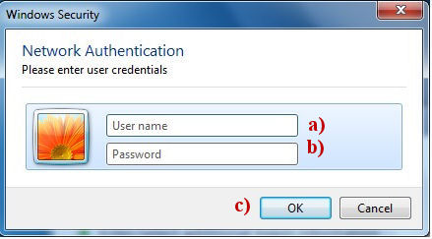
3. After a successful login, clicking on the network icon will display the following image:
